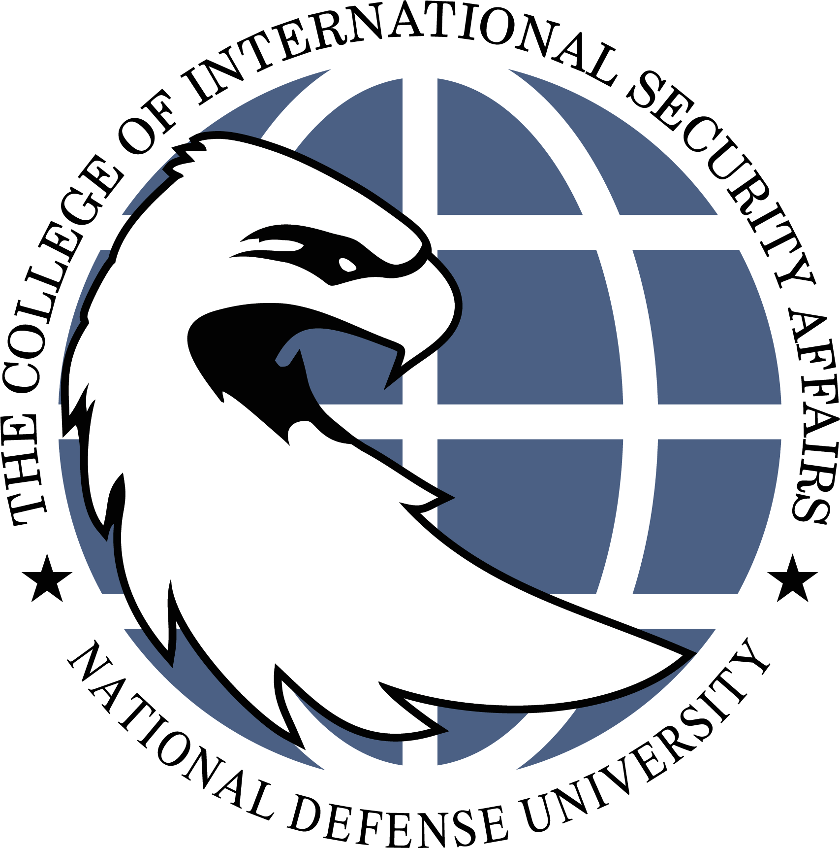
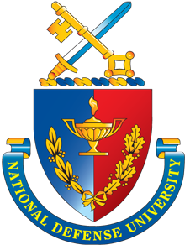
NATIONAL DEFENSE UNIVERSITY
College of International Security Affairs
Date | Agenda Highlights
Monday, 3 Aug  CISA Orientation Day 1: College and Student Life Introduction | Coffee Social  Chancellor Welcome  Dean of Students Welcome  - CISA Student Introductions  - CISA History  - Student Events and Experience  - Student Council Overview  - CISA Student Portal  - Seminar Assignments  Orientation Schedule Review  NDU Connect Profile  CISA Class President Interviews
Tuesday, 4 Aug  NDU Orientation | NDU Convocation Ceremony  NDU Leadership Welcome  NDU Student Orientation  *Lunch provided by Five and Thrive
Wednesday, 5 Aug  CISA Orientation Day 2: Academic Overview | Dean of Academic Programs Welcome  - Faculty Introductions  - Degree Requirements and Graduation Criteria  - Academic Year and Program Overview  - Practitioner Engagement and Academic Travel  - Academic Advising and Research Portfolio  - Elective Courses and Enrollment Process  - Academic Conduct Briefing
Thursday, 6 Aug  CISA Orientation Day 3: Student Support and Services | Seminar Room Breakouts  - CISA Student Introductions  - CISA Staff Introductions  - Educational Technology Overview  - Library Research Overview  - Writing Center Services  - NDU Health and Fitness Services  - NDU Connect Profile Status Update
Friday, 7 Aug  CISA Orientation Day 4: The CISA Network | CISA Alumni Network and Executive Board Overview  CISA Alumni Panel  Student–Alumni Social  Class of 2027 President Announced  Final Administration & Orientation Close-Out
Academic Year 2026-2027 Orientation for CISA Students
(All sessions begin at 0800 hours)

