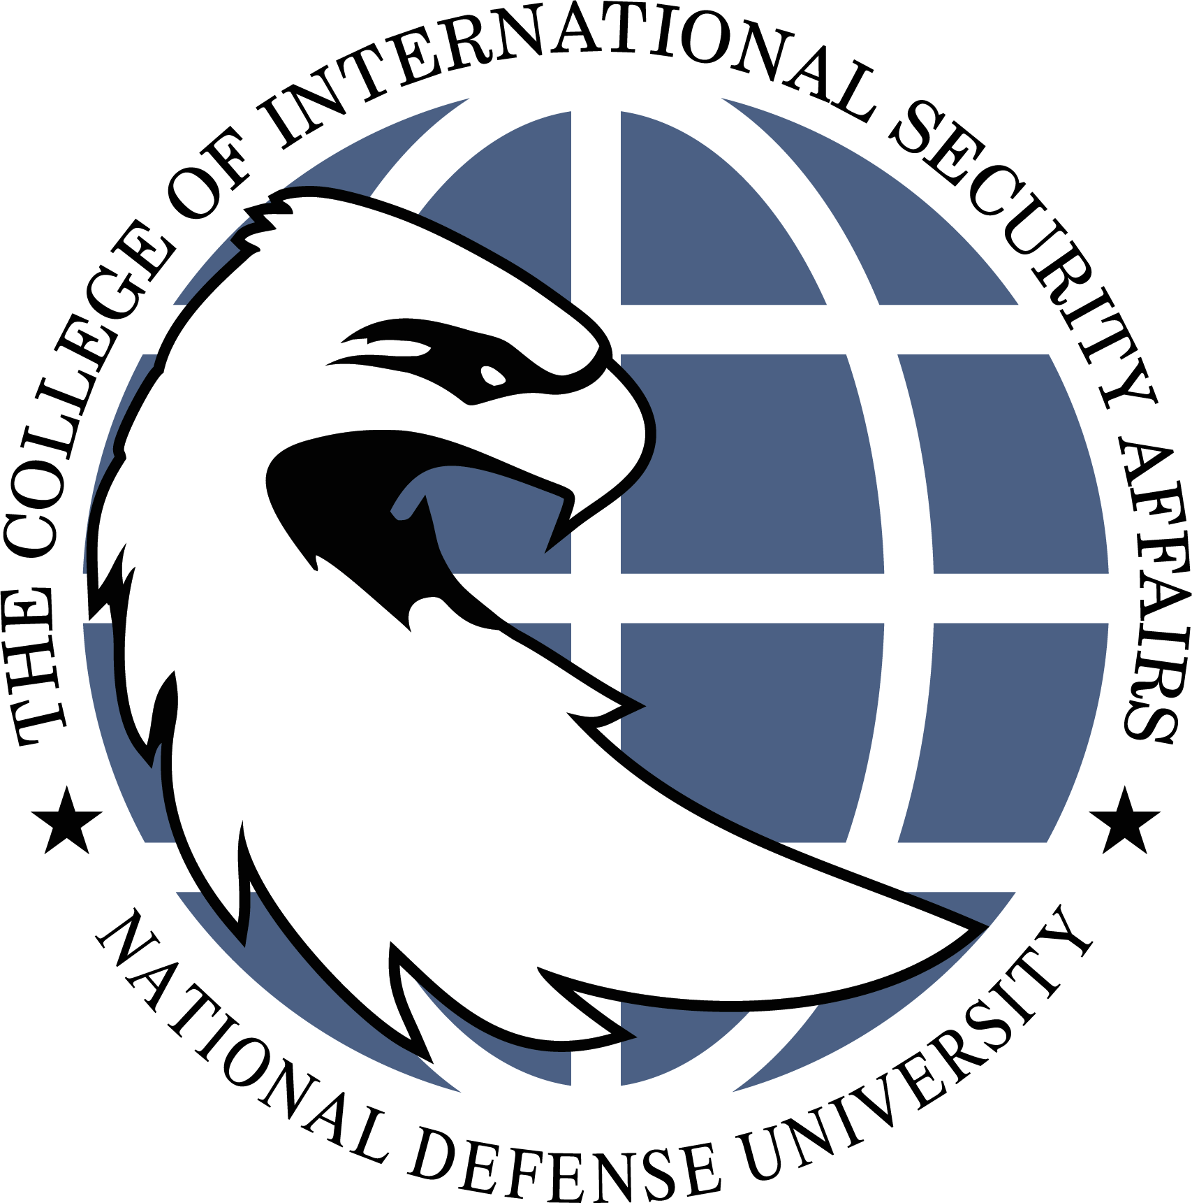
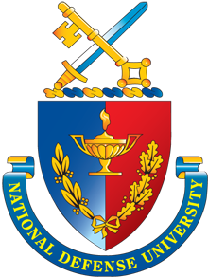
NATIONAL DEFENSE UNIVERSITY
College of International Security Affairs
Academic Year 2026-2027 Orientation for CISA JSOMA Students
Date | Agenda Highlights
Monday, 3 Aug  CISA Orientation Day 1 | JSOMA Department Chair Welcome  Faculty and Staff Introductions  Student Introductions  Dean of Academic Programs Welcome  LUNCH BREAK  Introduction to:  - Research and Analysis for Warfighters and Contemporary Challenges  - Graduate School, Ethics, and Academic Integrity  - Portfolio, Independent Research Project (IRP), and NDU Scholars
Tuesday, 4 Aug  NDU Orientation | NDU Convocation Ceremony (virtual)  Student Computer and Badge Draw  LUNCH BREAK  Dean of Students Welcome  Student Detachment In-Brief  Alumni Association Briefing  JSOMA Class President Interviews
Wednesday, 5 Aug  CISA Orientation Day 2 | Gaming and Simulation Exercise  LUNCH BREAK  Gaming and Simulation Exercise  JSOMA Electives Briefing
Thursday, 6 Aug  CISA Orientation Day 3 | Administration In-Brief  - SWCS Security In-processing  LUNCH BREAK  Chancellor Welcome  SWCS CG Welcome
Friday, 7 Aug  CISA Orientation Day 4 | Student / Portfolio Advisor Meetings

